How to Create a .kml File

For those of you who feel smartphone savvy, you can create your own .kml file for your route! This is the format we use to upload the routes to PollardBase. If you don’t want to do this yourselves or don’t have a smart phone, don’t worry! We can arrange to have someone walk the route with you once to record the map, or you can give us a map in whatever format you prefer and we can map it ourselves.

You can also map out your route on Google Earth Pro or a similar program and save the file as a .kml and send it to us that way. Whatever works best for you will work for us!

If you do want to use our smartphone to create a .kml file, the instructions for using Backcountry Nav Topo are below. If you have an Iphone, you can use MotionX GPS, which uses the same concepts, but I unfortunately do not have step-by-step instructions for MotionX GPS yet.
Using Backcountry Navigator

Download the free “Backcountry Nav Topo Maps” app. I’ve also heard that MotionX GPS works well, but it is only available for IPhones.

Open the app and click on the small folder icon to start a new Trip Database.

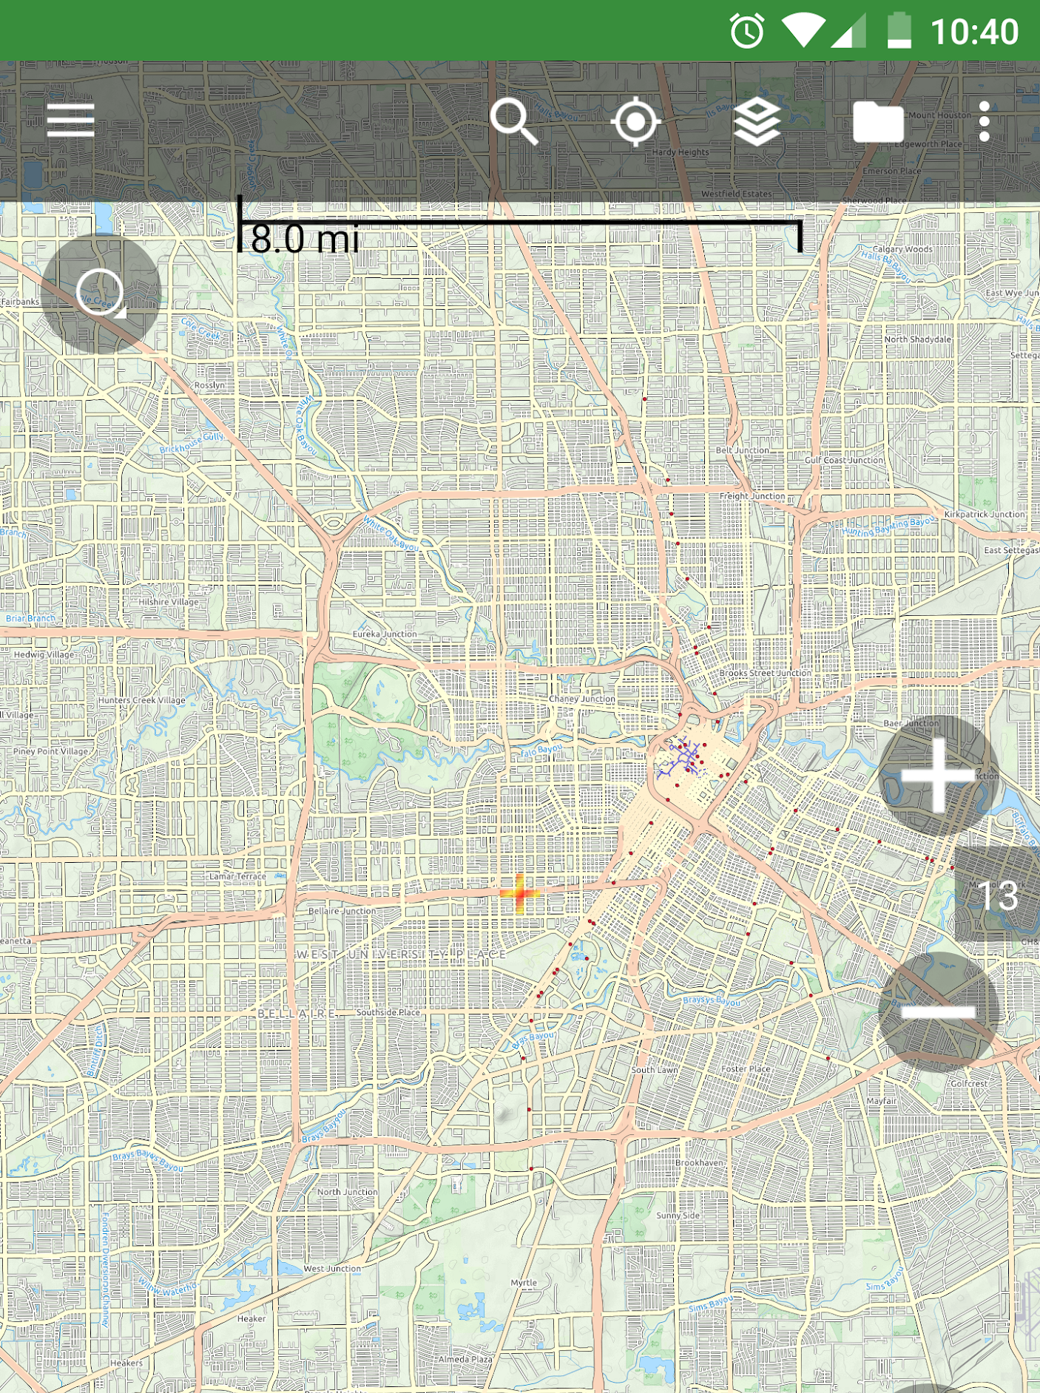

Click here

The Trip Database information page will open:

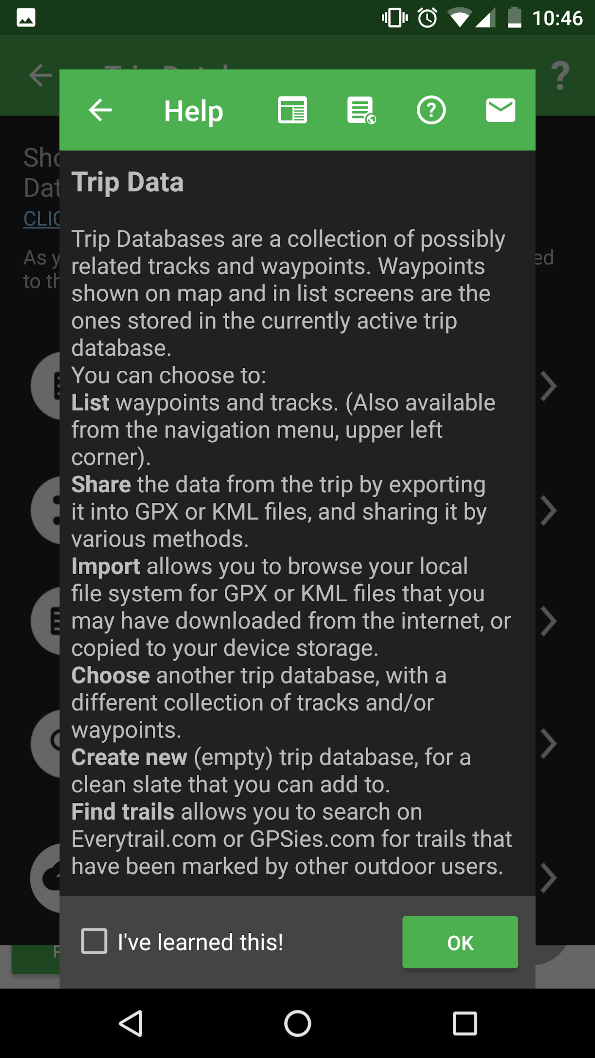

Then click here
Click here

Give it a name that is easy to remember (preferably the name of your location)

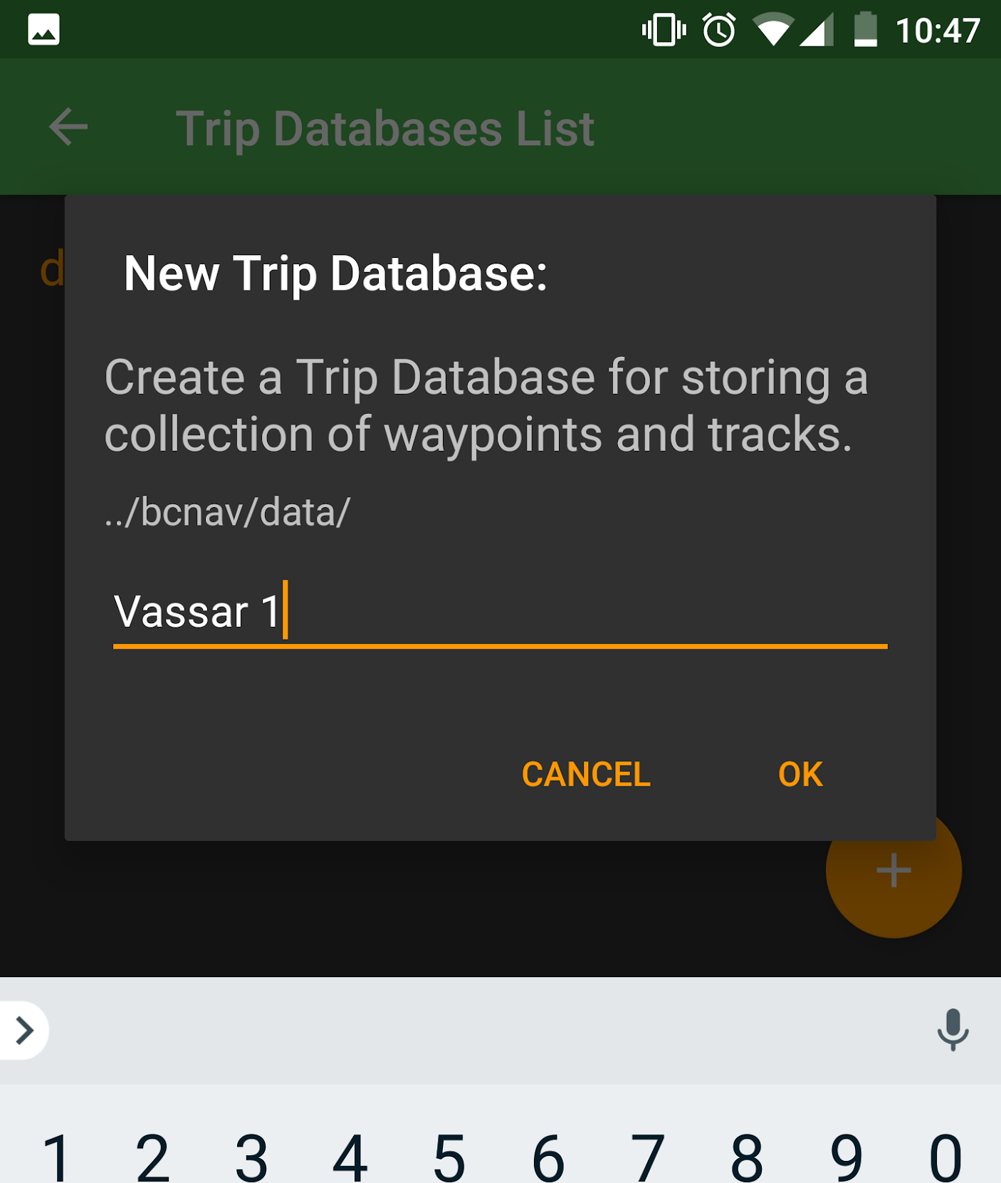

Click on the “my location” button at the top, then click on “Record a Track”

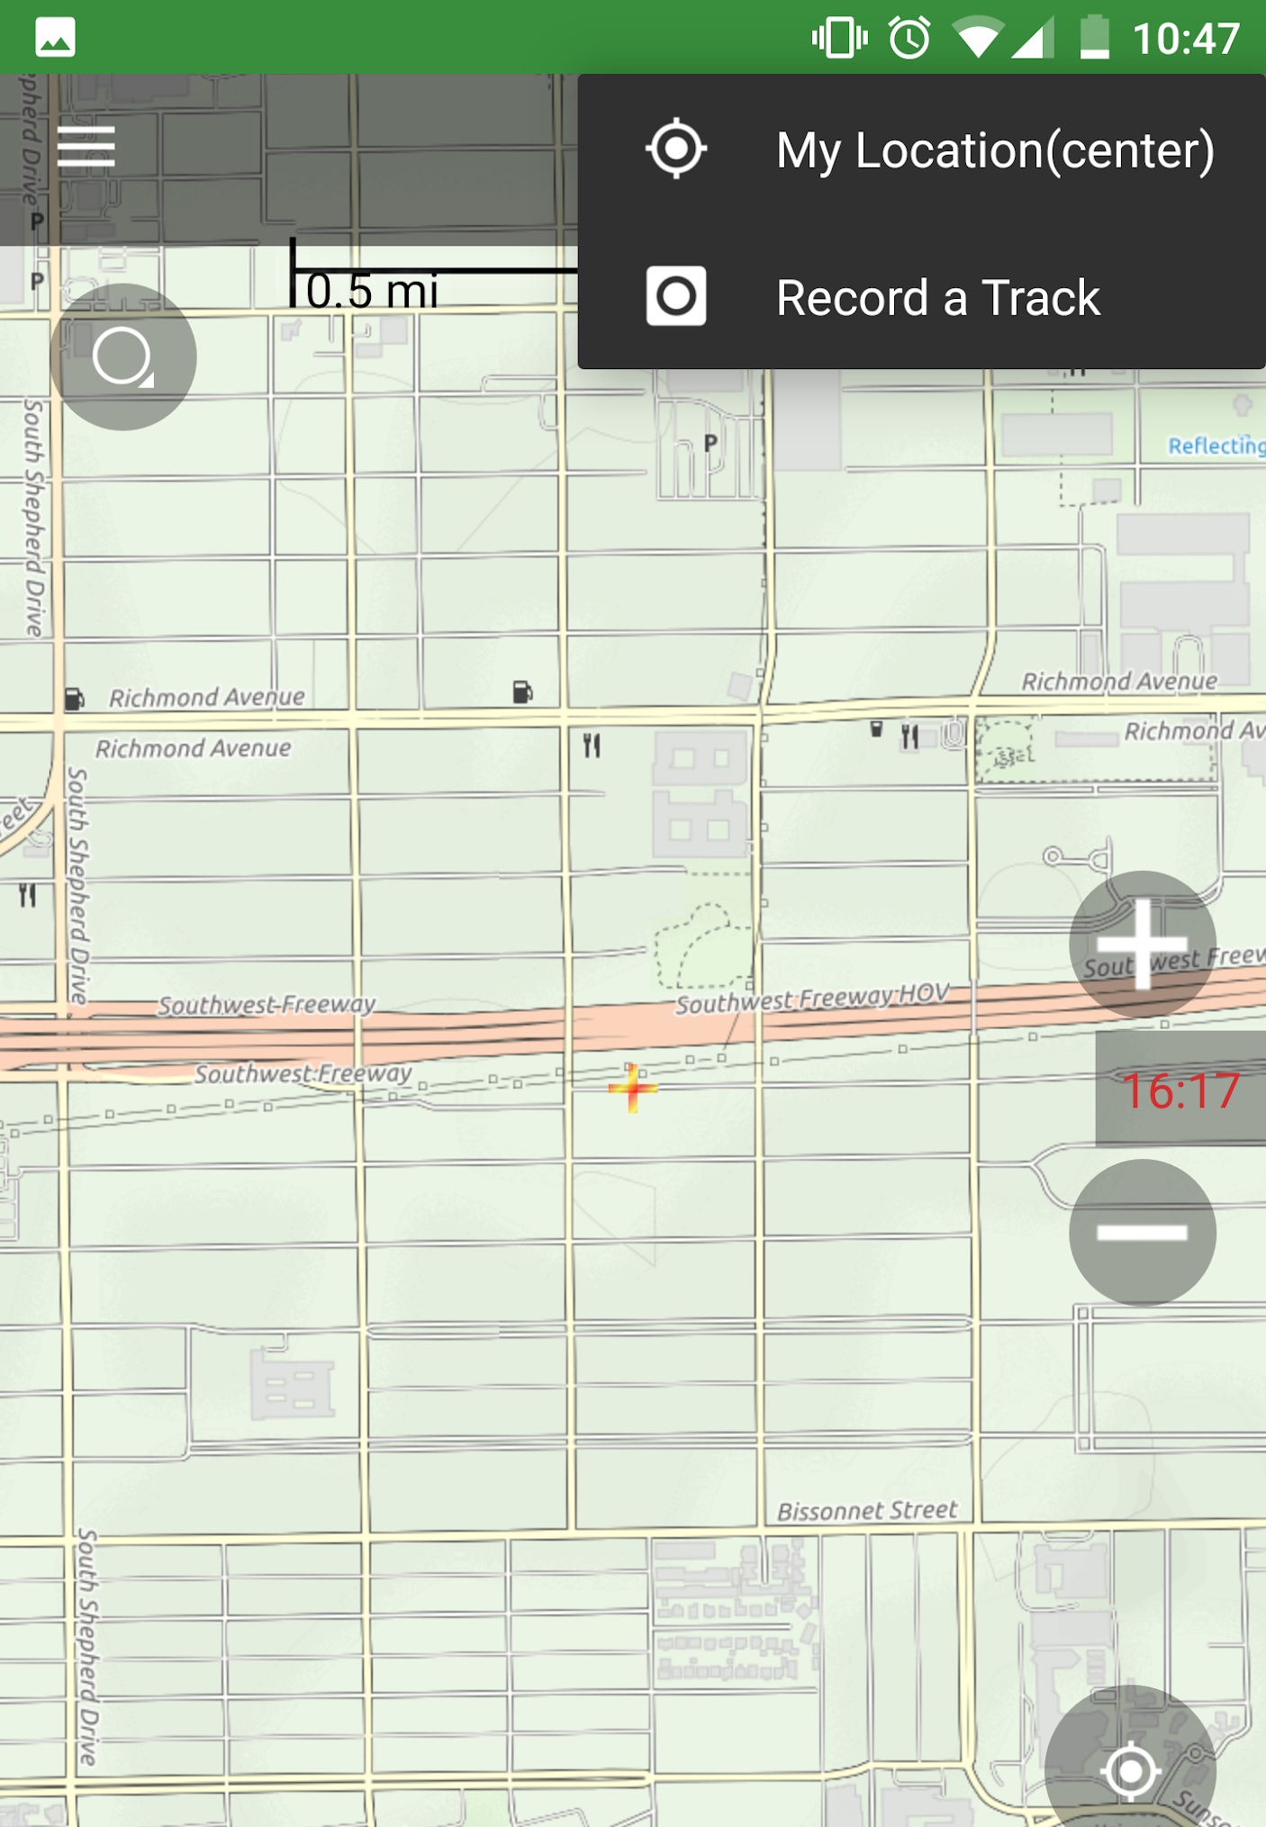

Then click here

Click here

Give your route a name and start recording!

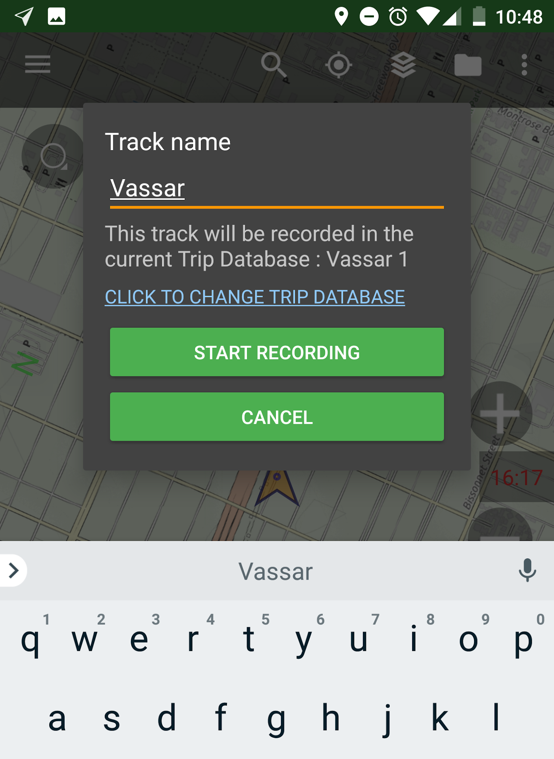

Then click here

Name your Route
Before you start walking, create a “start” waypoint

Make sure to save!

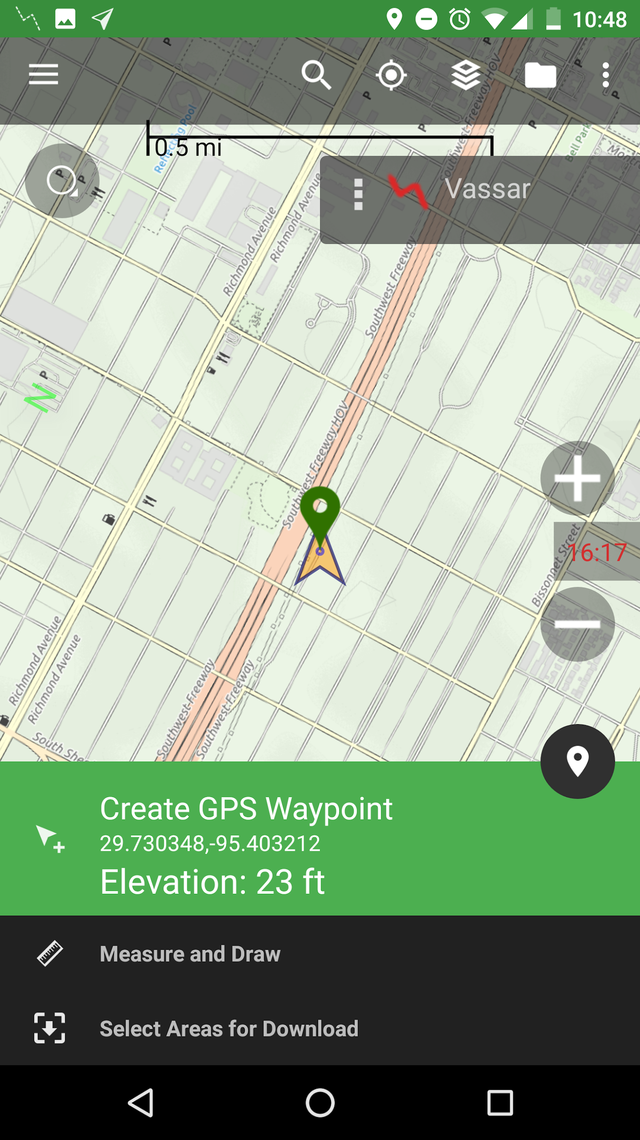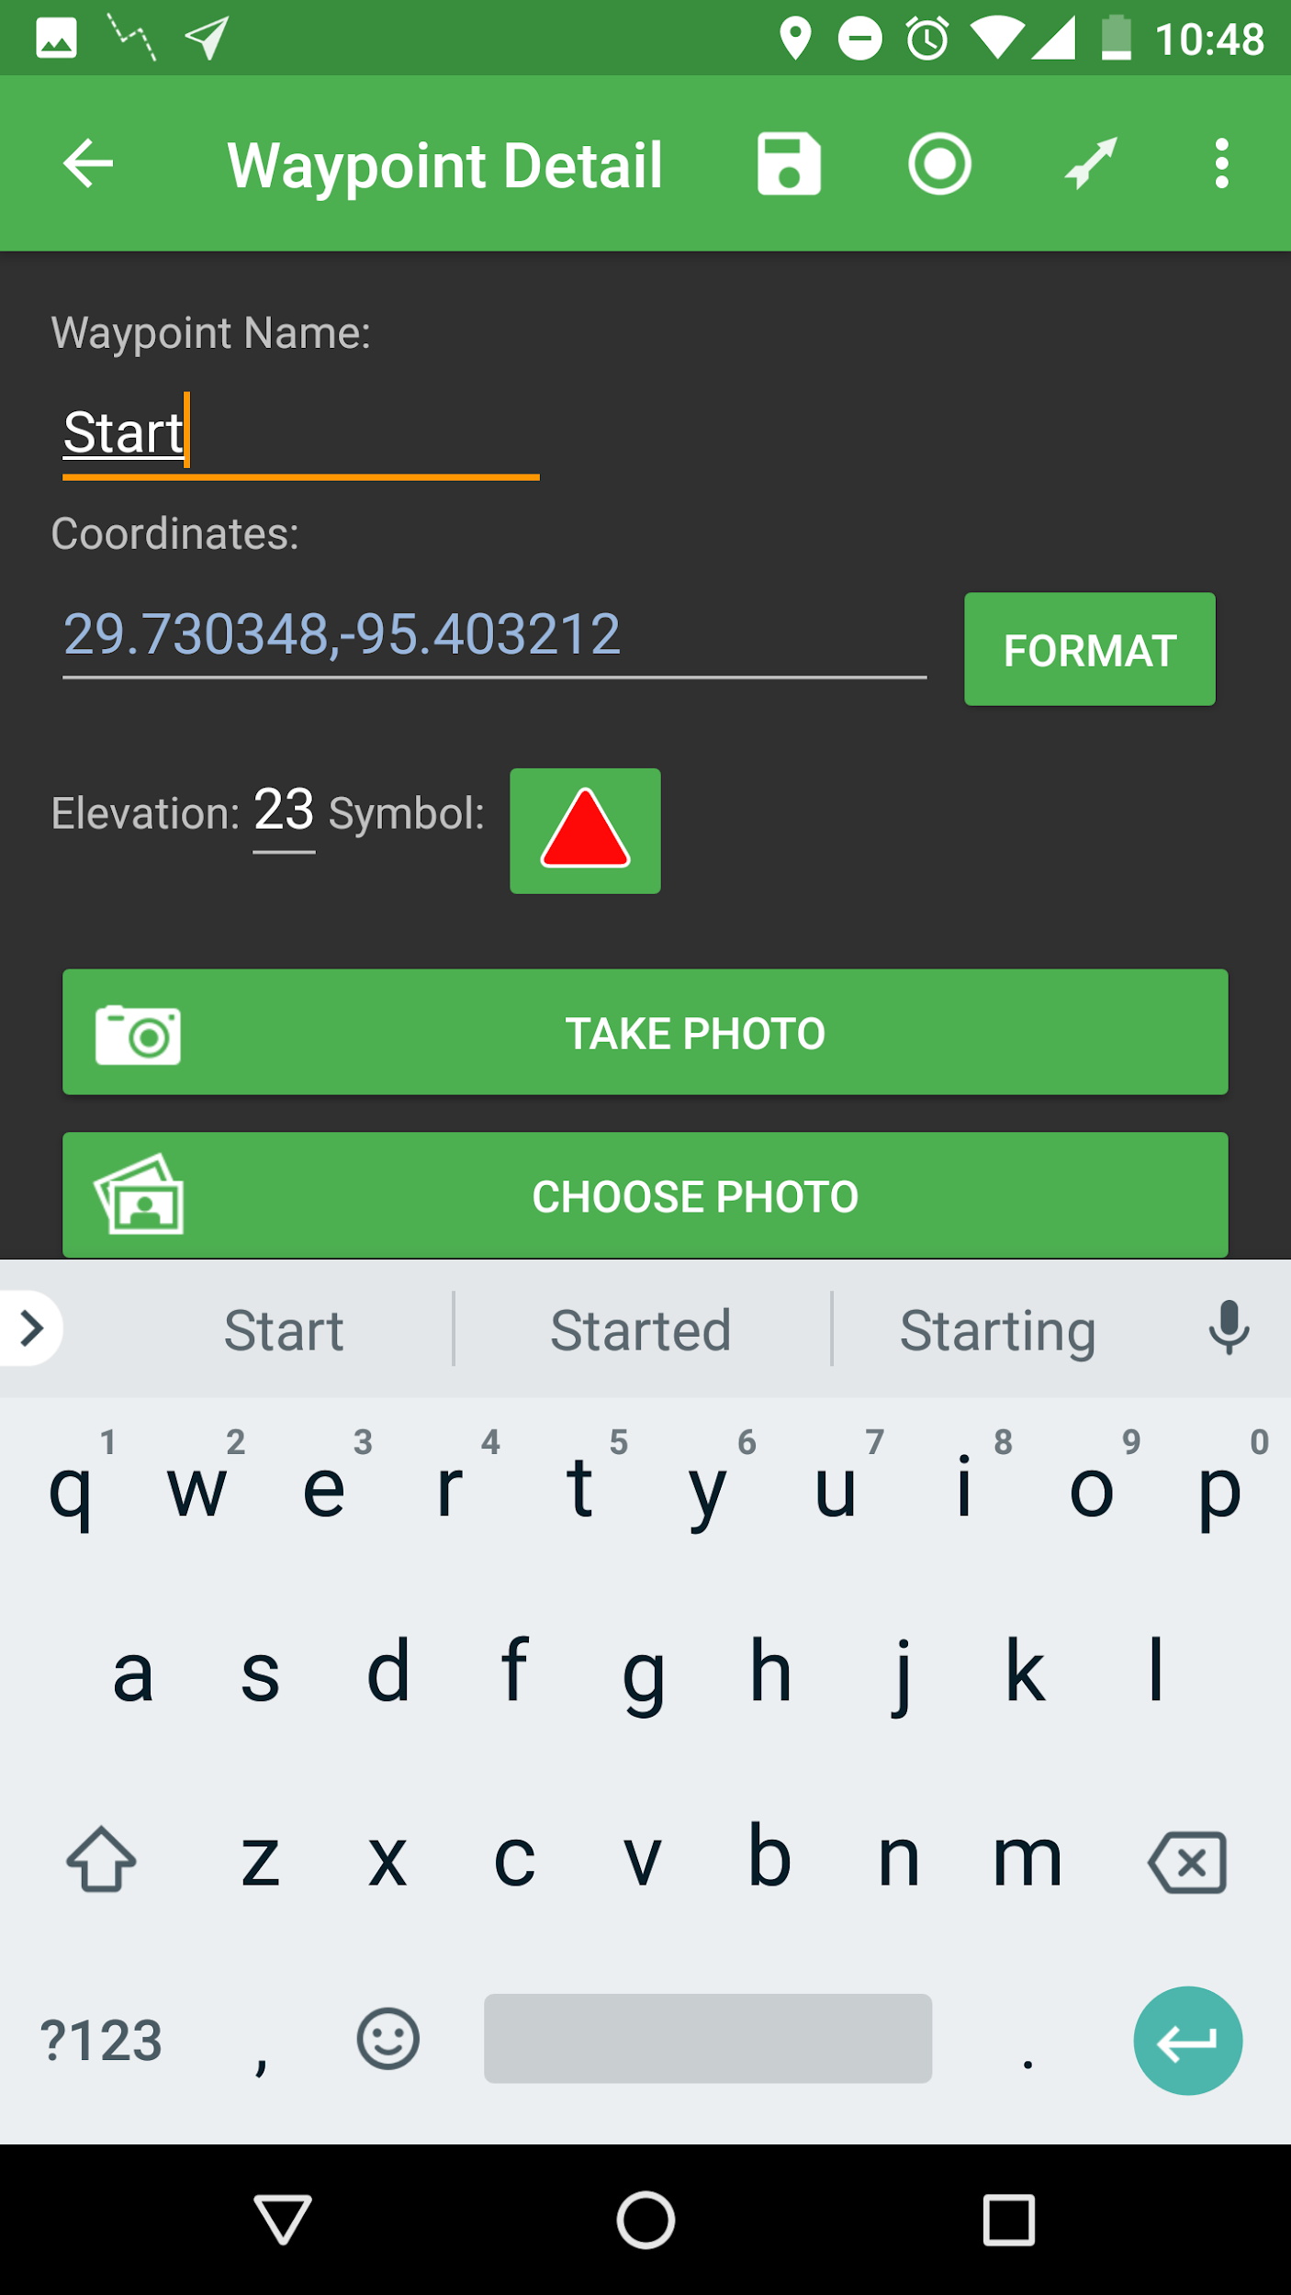

name waypoint “start”
Click icon
then click here

Start Walking!

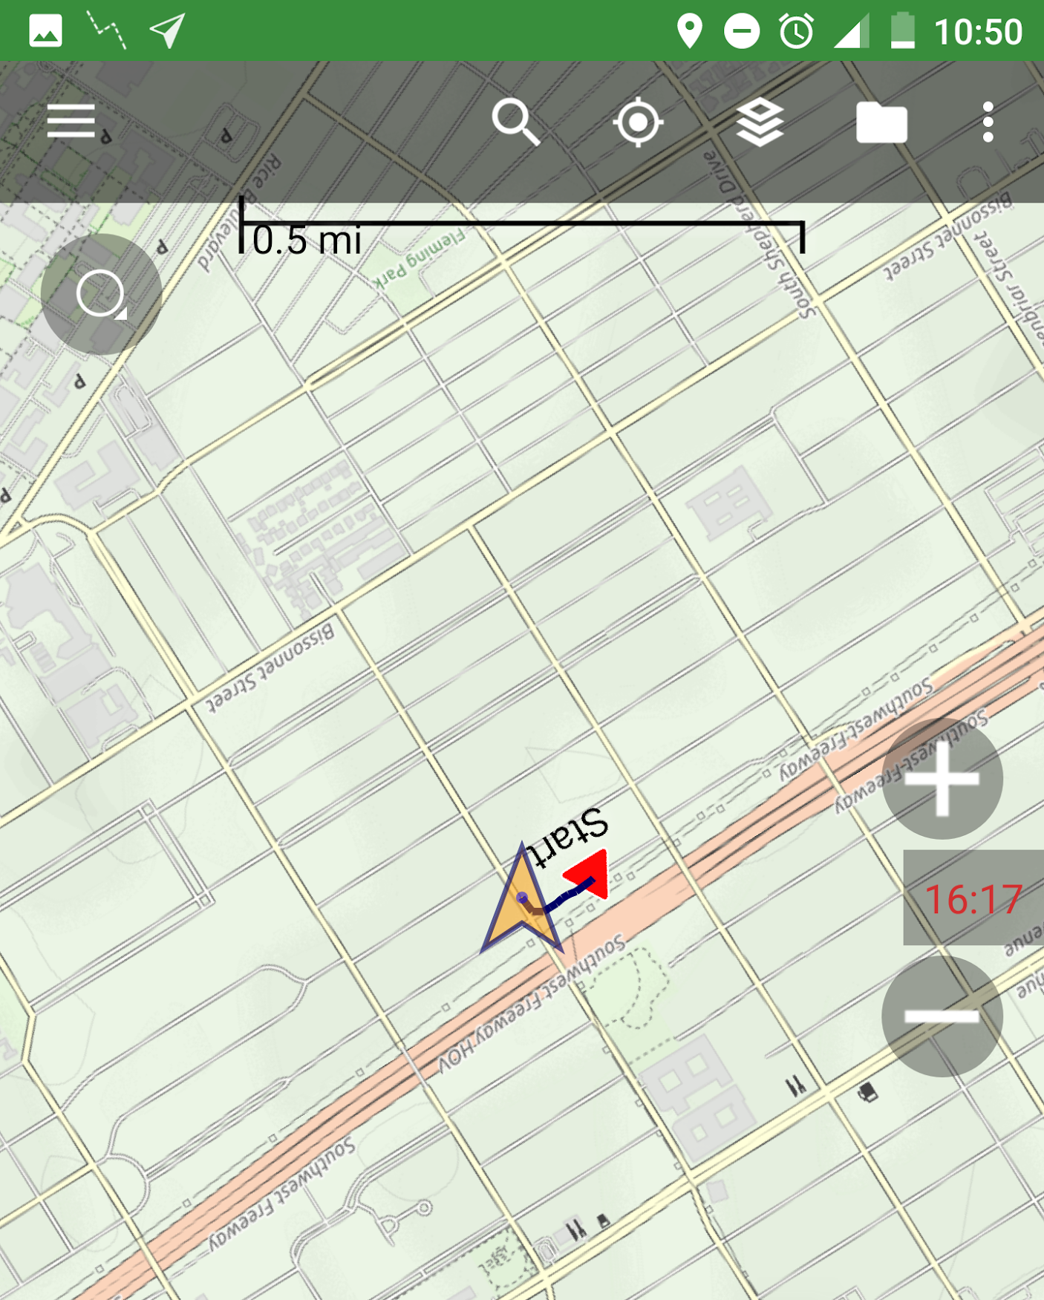
When you hit a new habitat, make a new Waypoint:

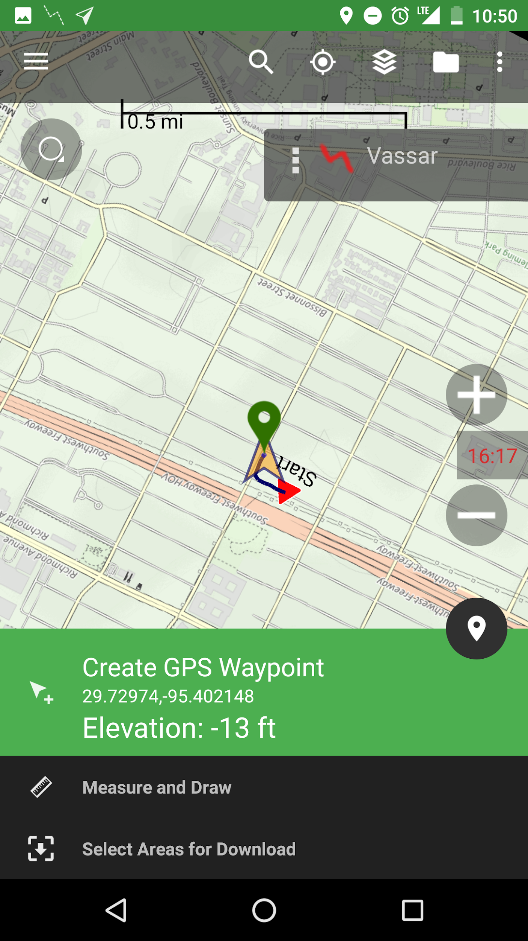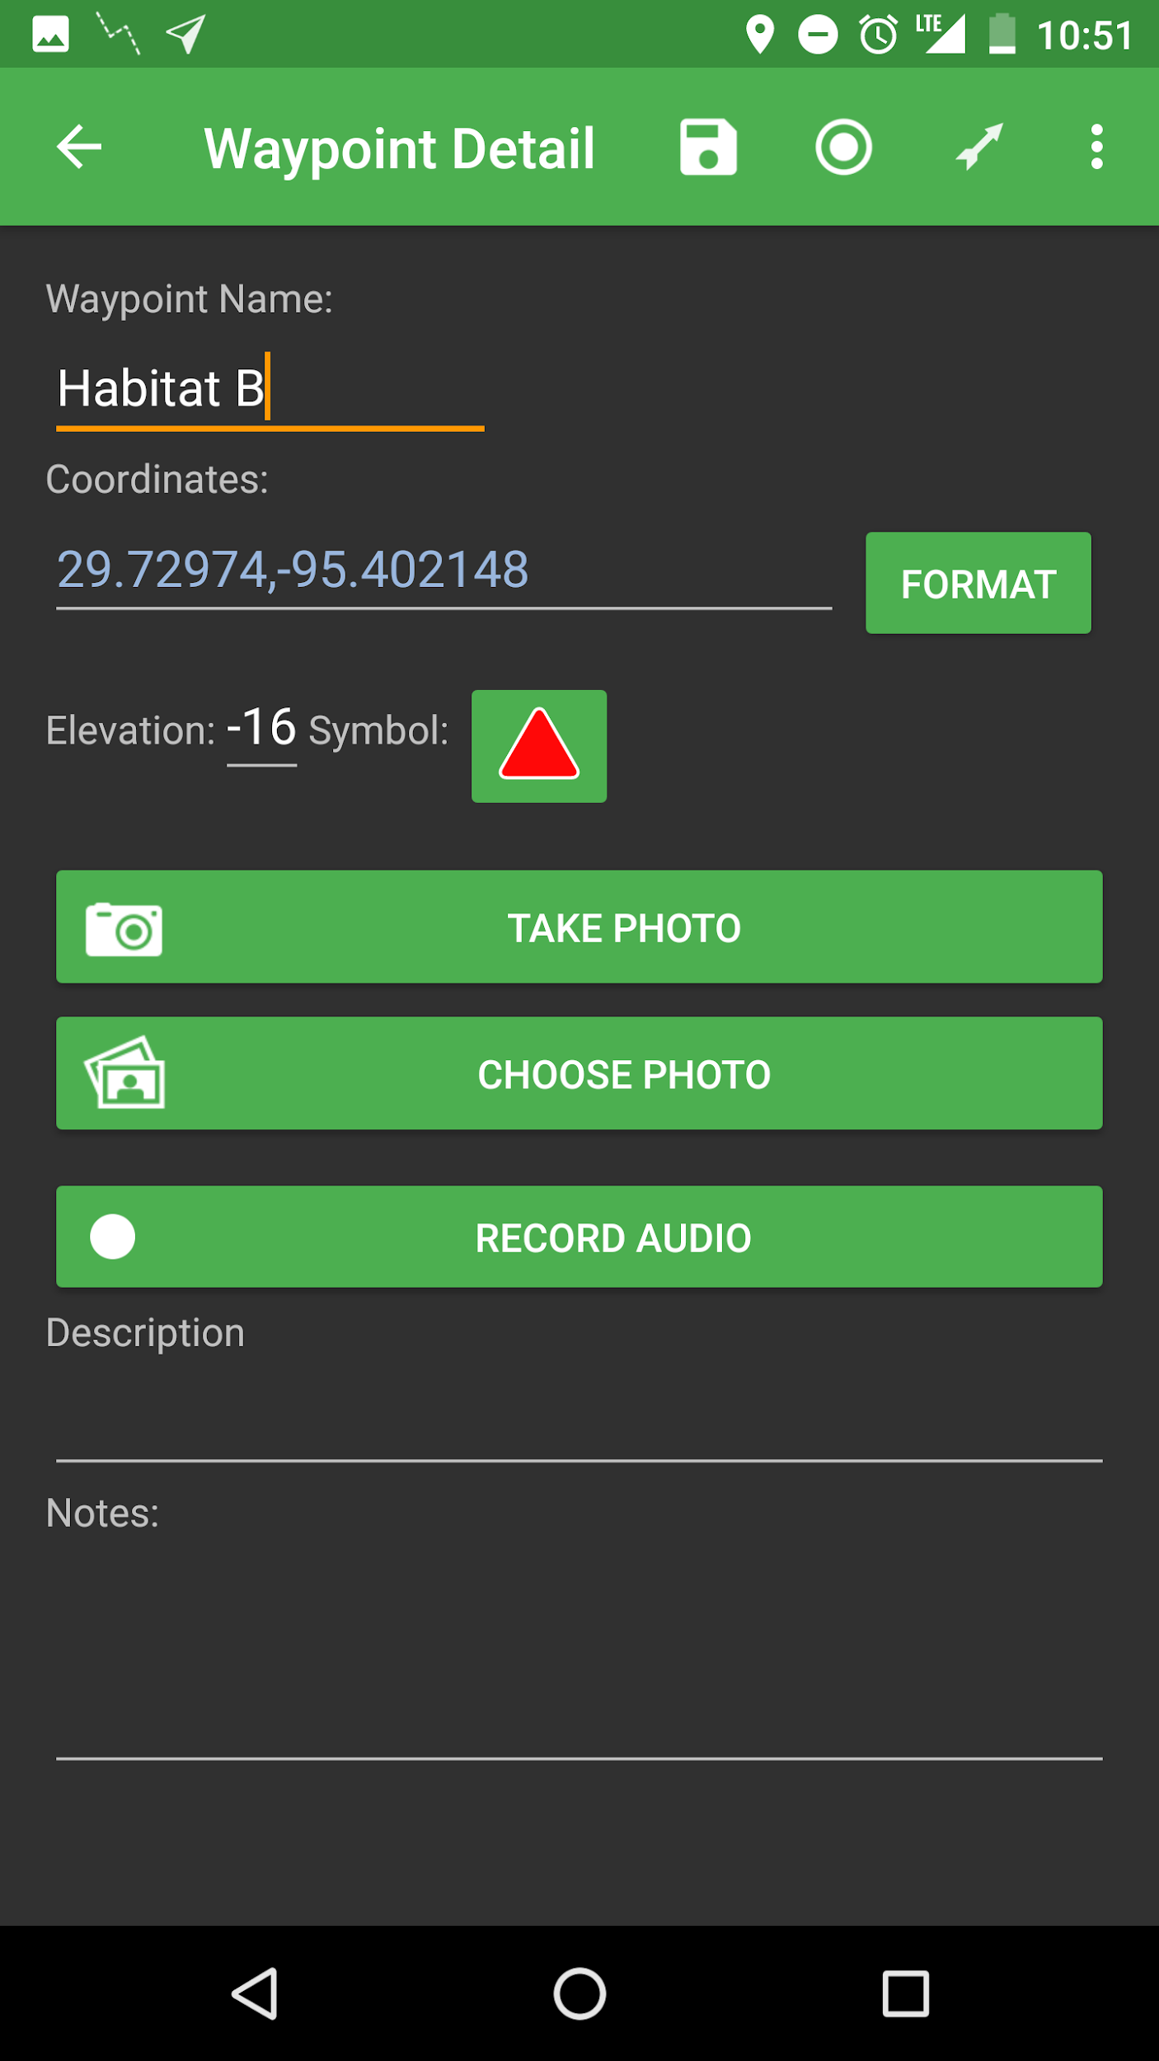

And continue in the same way until you get to the end of your route:

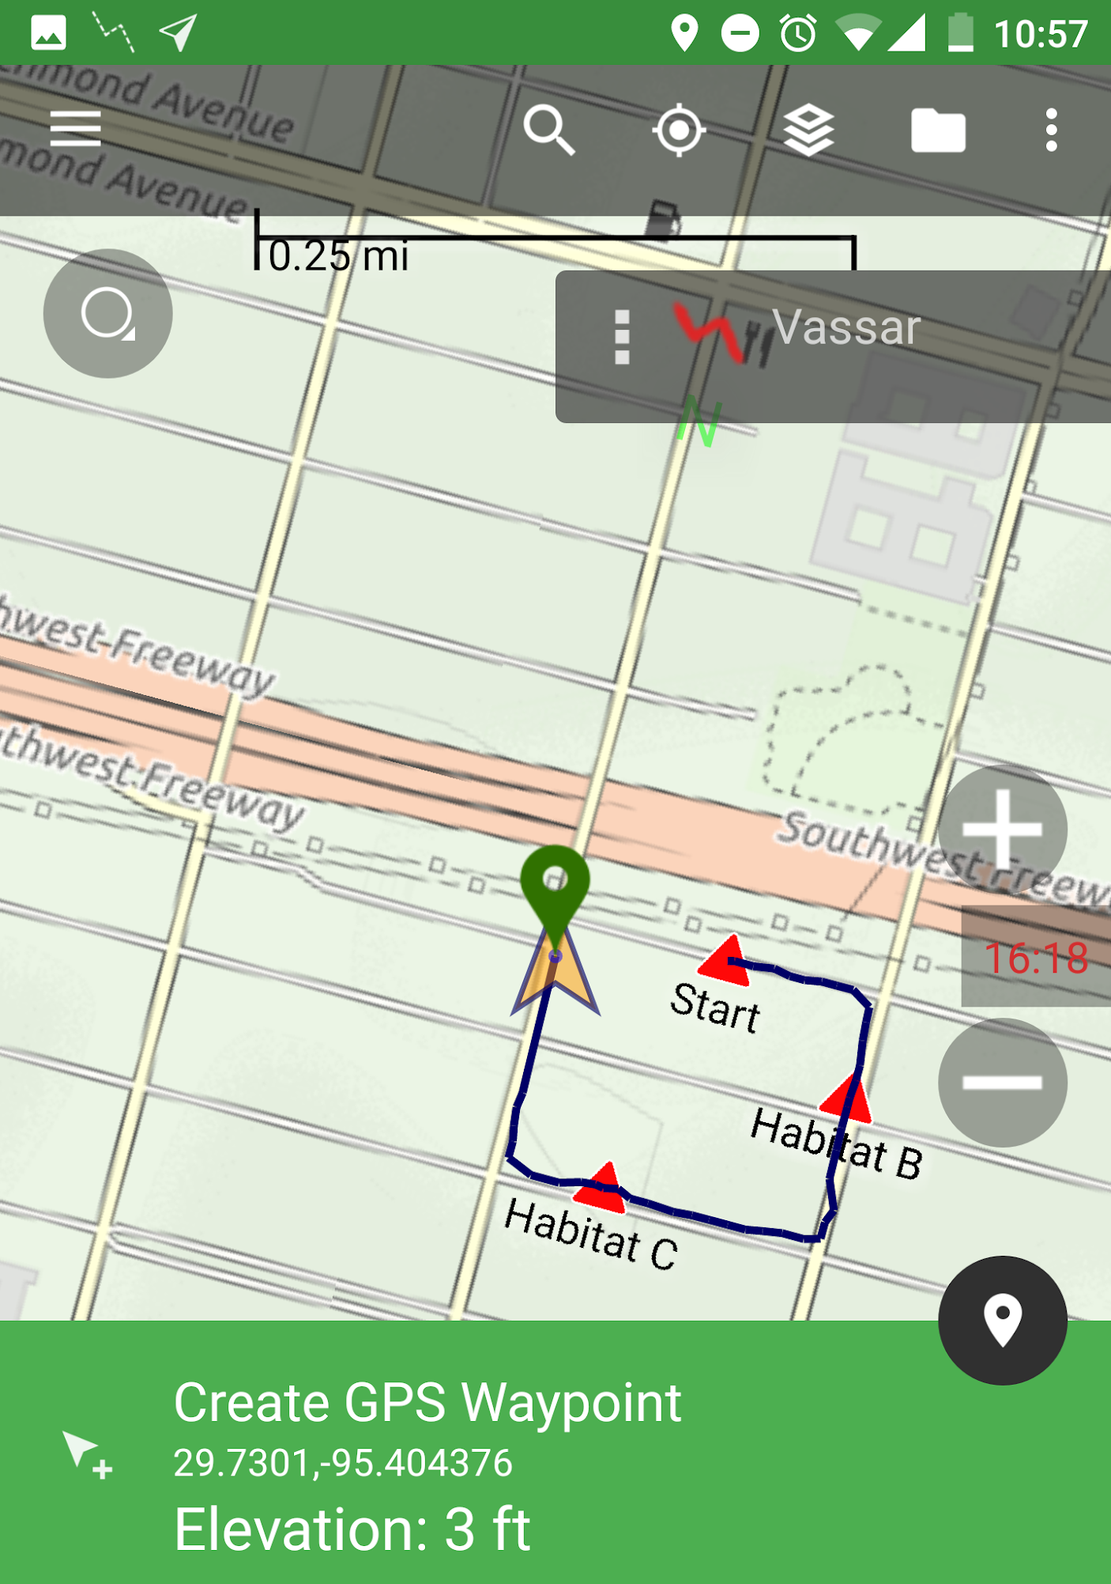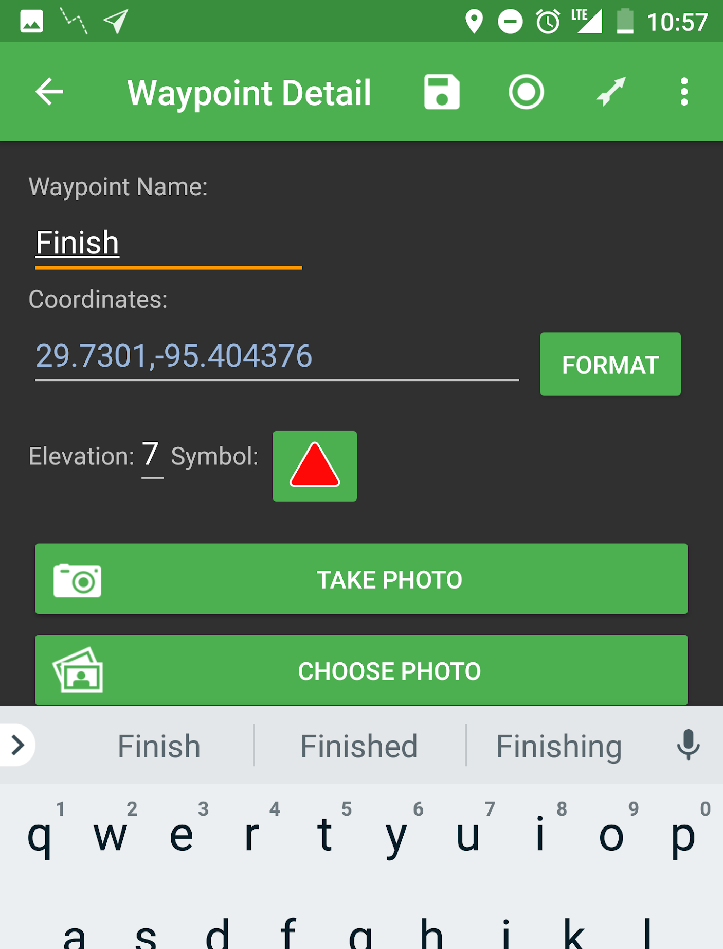

Once you finish your route, click the menu and go to “Share the data from the trip”

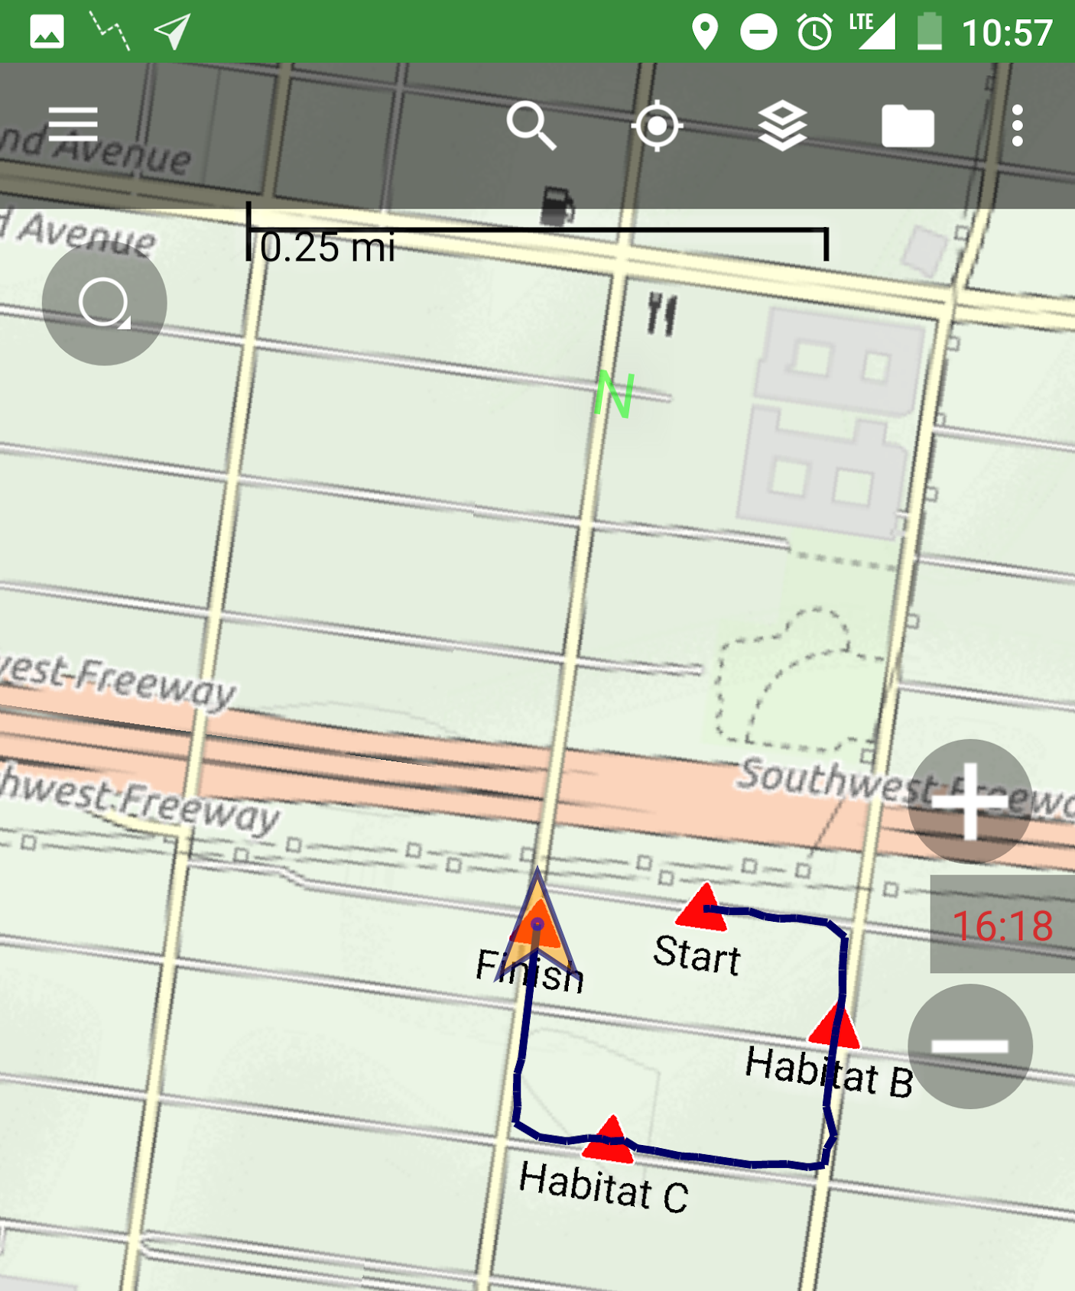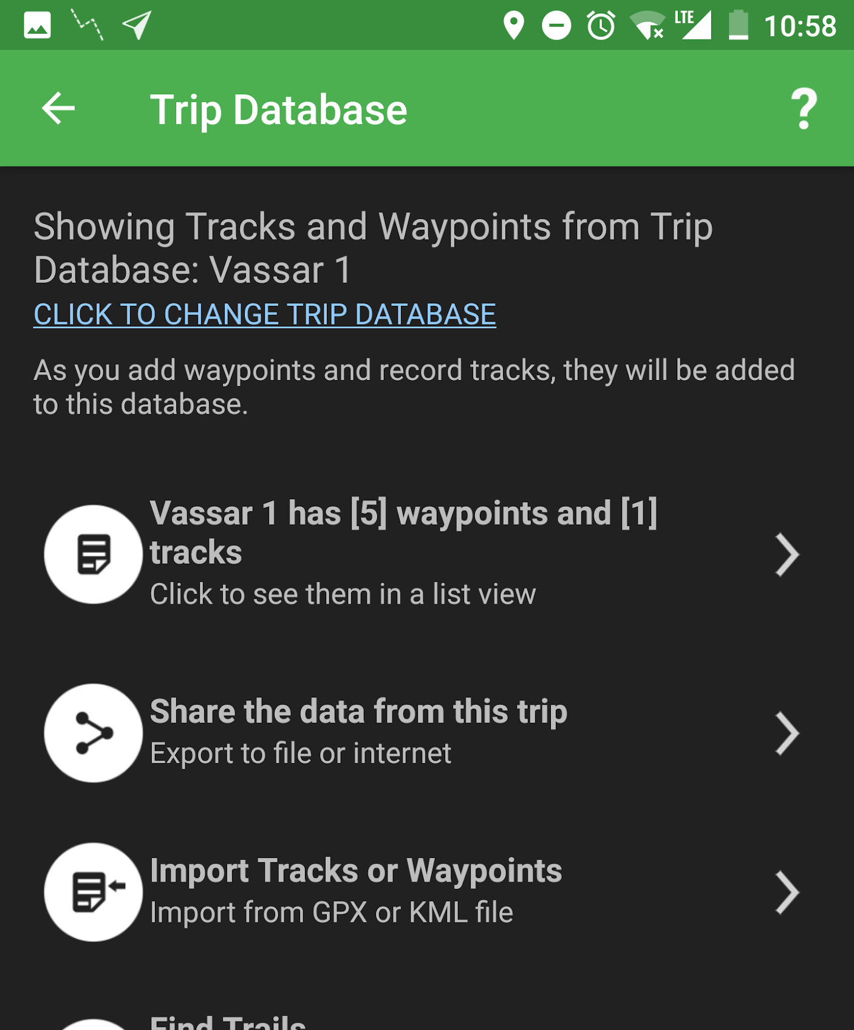

Menu icon
share data

Change .gpx to .kml and export

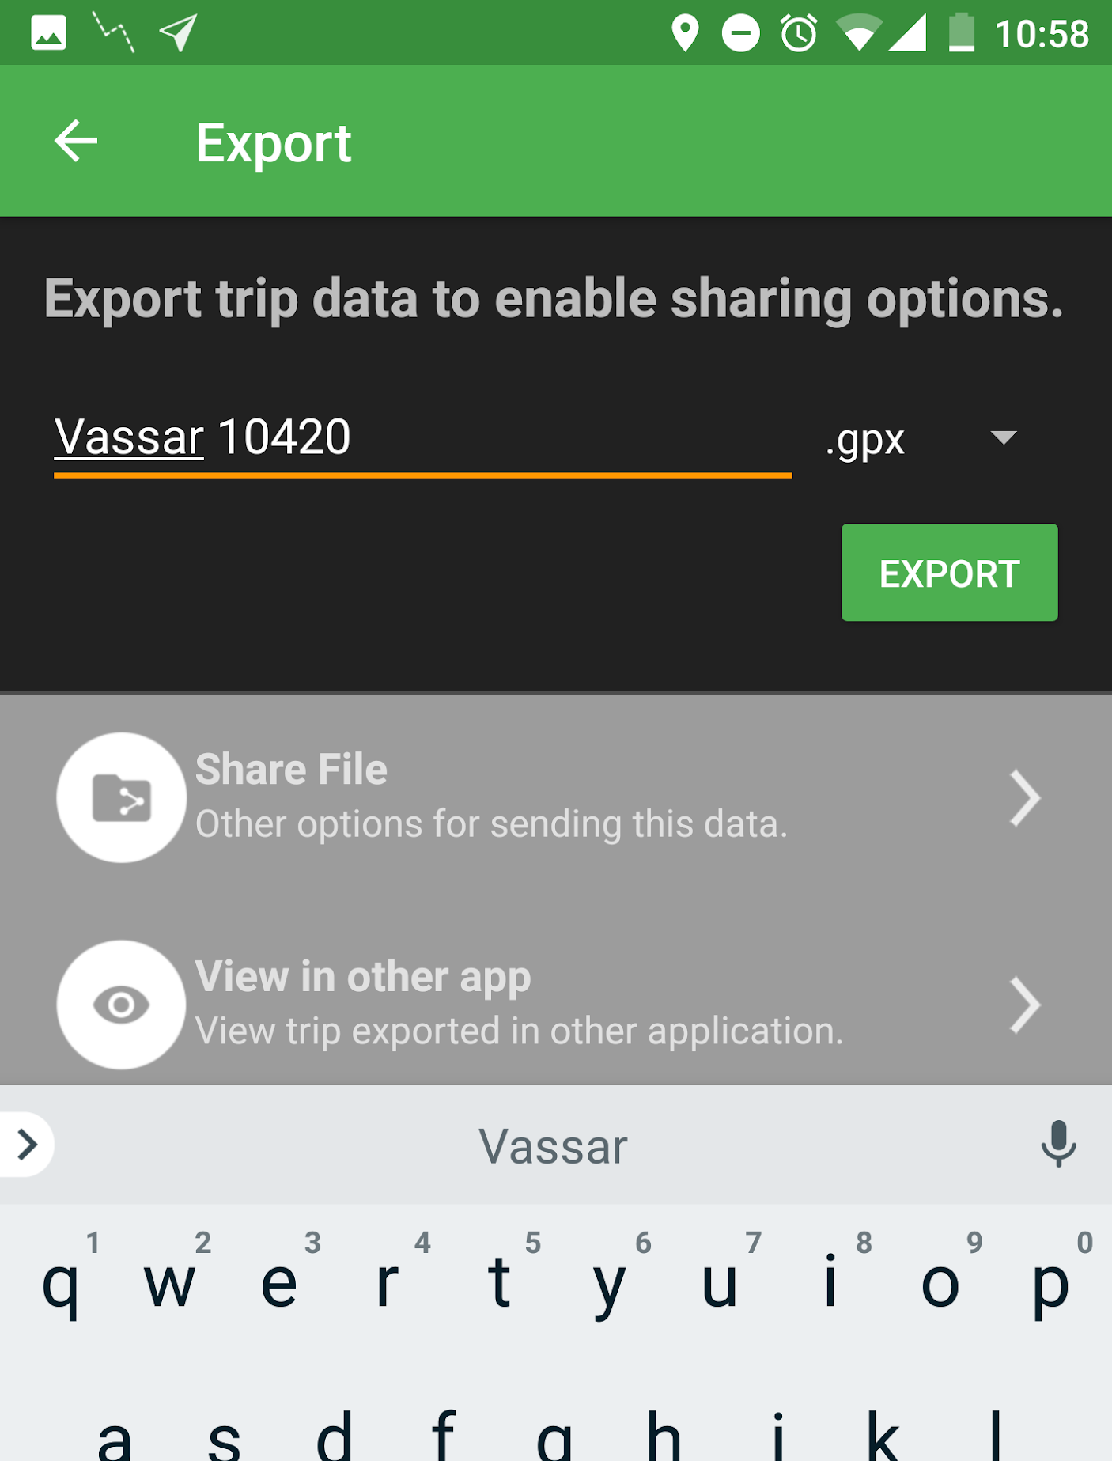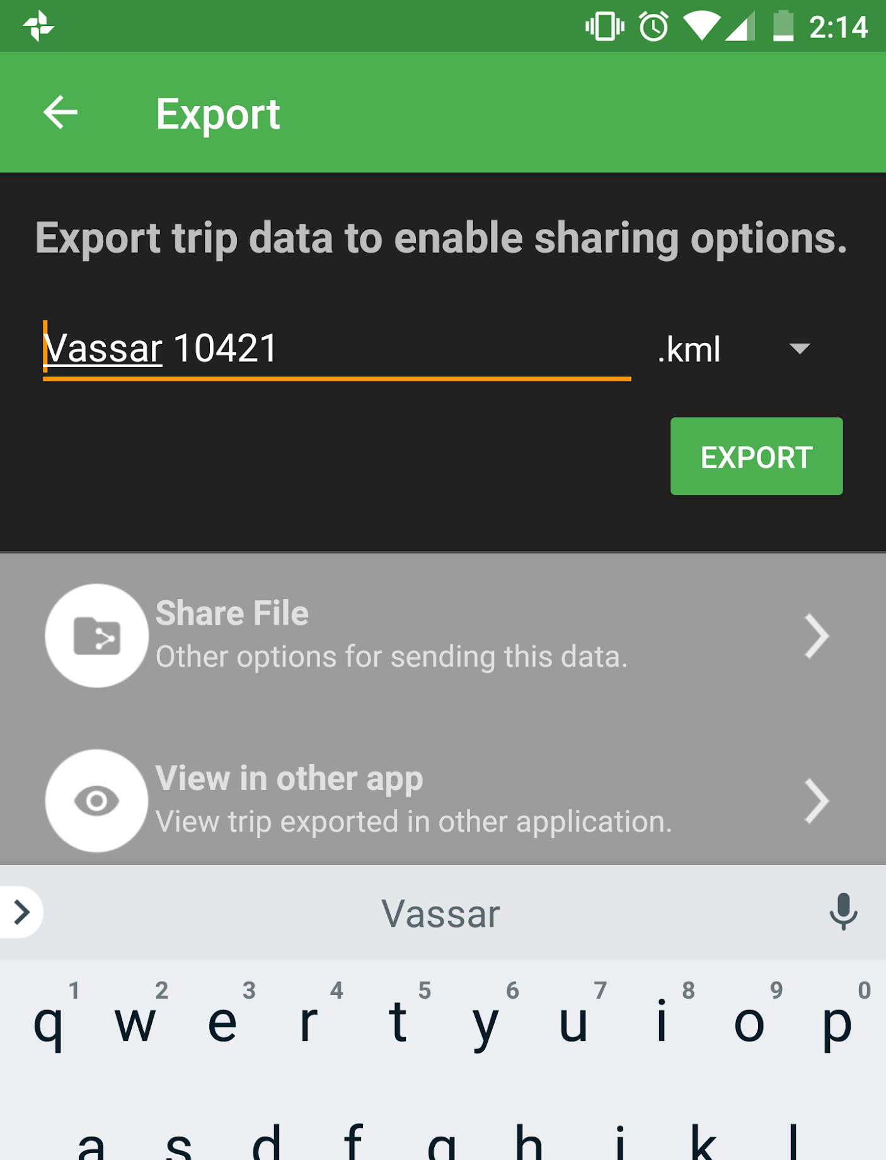
change to .kml

export

After exporting, click “share file” and email to khokamp@hmns.org

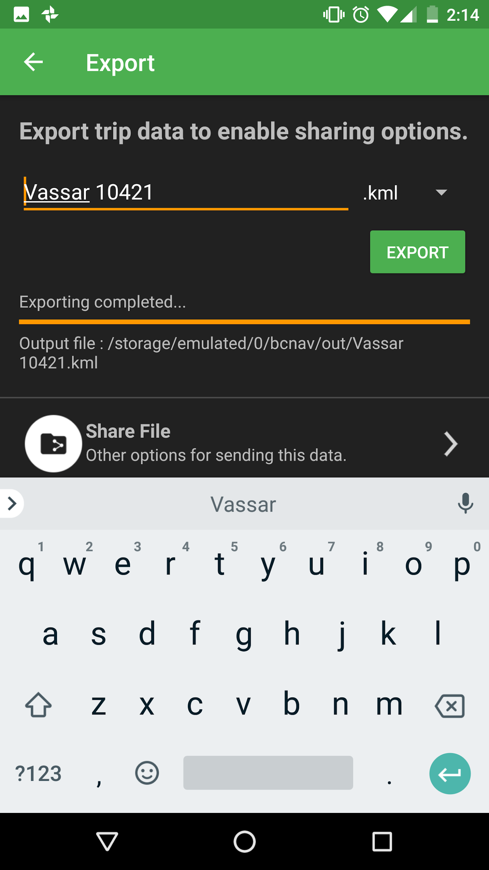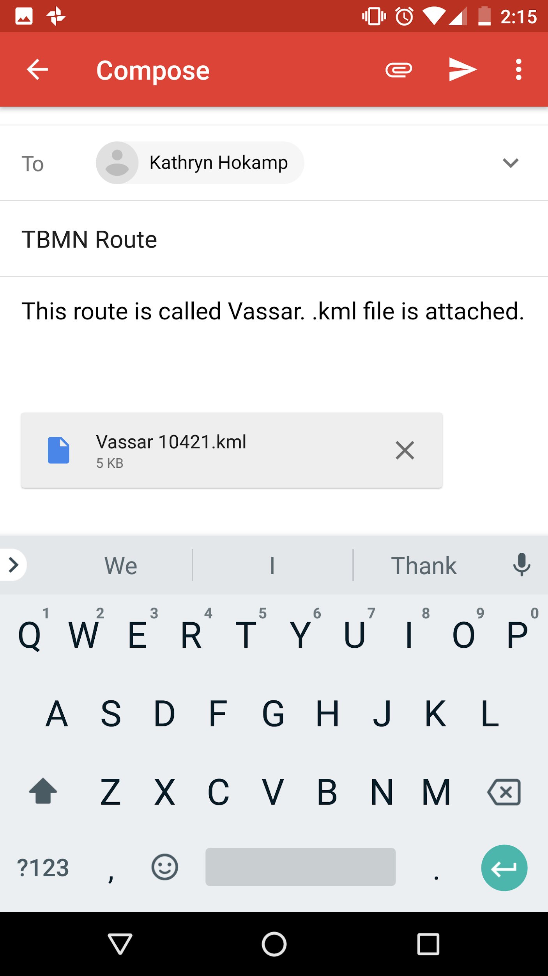

share file

Your map is done and sent in the correct file format! Good job!

